Project Planning Phase
Project Planning Template (Product Backlog, Sprint Planning, Stories, Story Points)
Date | 17 June 2026
Team ID | -------------------------
Project Name | ShopEZ - Full Stack E-Commerce Platform
Maximum Marks | 5 Marks

Product Backlog, Sprint Schedule, and Estimation
The following product backlog and sprint plan is prepared for the ShopEZ MERN e-commerce web application. The sprint schedule is planned between 10 Jun 2026 and 18 Jun 2026 because the project file was forwarded on 10th and the final deadline is 18th. ShopEZ includes user registration, JWT login, product catalog, cart, checkout with GST and delivery charges, order management, and admin product management.
Sprint | Functional Requirement (Epic) | User Story Number | User Story / Task | Story Points | Priority | Team Members
Sprint-1 | Project Setup | USN-1 | As a developer, I can set up the React frontend using Vite and create routes for Home, Products, Login, Register, Cart, Checkout, Orders, Profile, and Admin Dashboard. | 2 | High | Gajerla Praneeth
Sprint-1 | Backend Setup | USN-2 | As a developer, I can set up the Express backend, connect MongoDB, and create MVC folder structure with routes, models, controllers, and middleware. | 3 | High | Gajerla Praneeth
Sprint-1 | User Registration | USN-3 | As a user, I can register using username, email, and password so that I can create a ShopEZ account. | 3 | High | Gajerla Praneeth
Sprint-1 | Login & Authentication | USN-4 | As a user/admin, I can log in using email and password and receive a JWT token for secure access. | 4 | High | Gajerla Praneeth
Sprint-2 | Product Catalog | USN-5 | As a user, I can view all available products with image, title, description, and price. | 4 | High | Gajerla Praneeth
Sprint-2 | Product Details | USN-6 | As a user, I can open a product details page and see a larger image, description, price, and Add to Cart button. | 3 | High | Gajerla Praneeth
Sprint-2 | Cart Management | USN-7 | As a logged-in user, I can add products to cart, increase or decrease quantity, remove items, and view cart total. | 5 | High | Gajerla Praneeth
Sprint-2 | Protected Cart Access | USN-8 | As a system, I should prevent users from adding to cart or proceeding to checkout without login. | 5 | High | Gajerla Praneeth
Sprint-3 | Checkout | USN-9 | As a user, I can enter delivery details such as name, mobile, email, address, city, pincode, and payment method. | 4 | High | Gajerla Praneeth
Sprint-3 | Price Calculation | USN-10 | As a user, I can see subtotal, GST, delivery charges, and grand total before placing the order. | 3 | High | Gajerla Praneeth
Sprint-3 | Order Placement | USN-11 | As a user, I can place an order and store order details including items, totals, address, payment method, and date. | 5 | High | Gajerla Praneeth
Sprint-3 | Profile & Order History | USN-12 | As a user, I can view my profile details and order history after login. | 3 | Medium | Gajerla Praneeth
Sprint-4 | Admin Authorization | USN-13 | As an admin, I can access the admin dashboard only when my account role is admin. | 3 | High | Gajerla Praneeth
Sprint-4 | Admin Product Management | USN-14 | As an admin, I can add products, view products, and delete products from the ShopEZ database. | 5 | High | Gajerla Praneeth
Sprint-4 | Admin Order Management | USN-15 | As an admin, I can view all orders placed by users for monitoring and management. | 4 | High | Gajerla Praneeth
Sprint-4 | UI Polish & Documentation | USN-16 | As a developer, I can improve the dark/blue responsive UI, add hover effects, and prepare final project documentation. | 4 | Medium | Gajerla Praneeth

Project Tracker, Velocity & Burndown Chart
Sprint | Total Story Points | Duration | Sprint Start Date | Sprint End Date (Planned) | Story Points Completed | Sprint Release Date (Actual)
Sprint-1 | 12 | 2 Days | 10 Jun 2026 | 11 Jun 2026 | 12 | 11 Jun 2026
Sprint-2 | 17 | 2 Days | 12 Jun 2026 | 13 Jun 2026 | 17 | 13 Jun 2026
Sprint-3 | 15 | 2 Days | 14 Jun 2026 | 15 Jun 2026 | 15 | 15 Jun 2026
Sprint-4 | 16 | 3 Days | 16 Jun 2026 | 18 Jun 2026 | 16 | 18 Jun 2026
Total | 60 | 9 Days | 10 Jun 2026 | 18 Jun 2026 | 60 | 18 Jun 2026

Velocity
Velocity describes how many story points were completed in each sprint. For ShopEZ, the planned story points are 60 across 4 sprints from 10 Jun 2026 to 18 Jun 2026. Average velocity per sprint = 60 / 4 = 15 story points per sprint. Average work rate = 60 story points / 9 days = 6.67 story points per day.
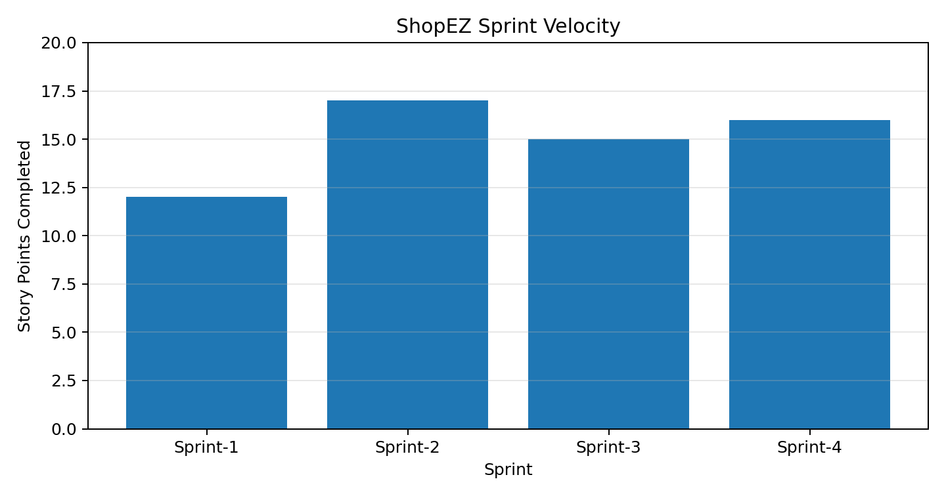

Burndown Chart
The burndown chart shows the remaining story points from 10 Jun 2026 to 18 Jun 2026. It helps track whether the project is moving toward completion as planned before the final submission deadline.
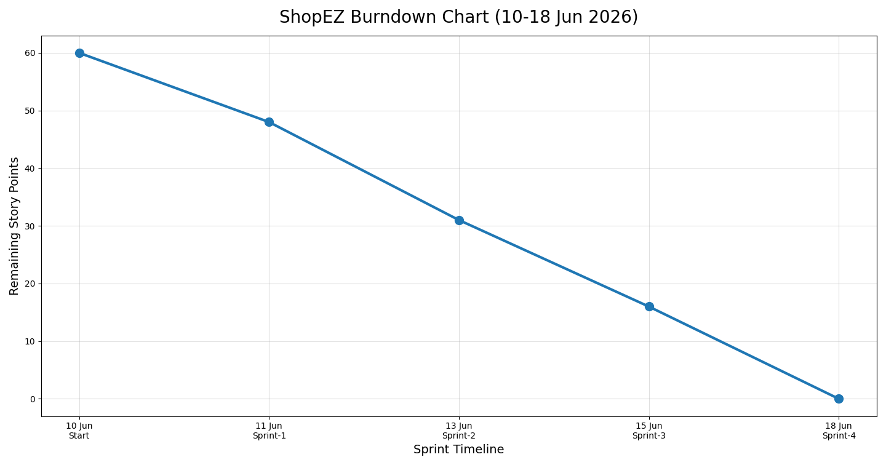

Sprint-wise Deliverables
Sprint | Main Deliverables | Output
Sprint-1 | Frontend setup, backend setup, MongoDB connection, user registration, JWT login | Authentication and base MERN structure completed
Sprint-2 | Products page, product details, cart quantity, login protection for Add to Cart and Checkout | Shopping flow completed
Sprint-3 | Checkout form, subtotal/GST/delivery charges, order placement, profile/order history | Order flow completed
Sprint-4 | Admin dashboard, admin product management, all orders, UI polish, final documentation | Admin flow and final submission completed

References
Atlassian Agile Project Management: https://www.atlassian.com/agile/project-management
Atlassian Epics: https://www.atlassian.com/agile/tutorials/epics
Atlassian Sprints: https://www.atlassian.com/agile/tutorials/sprints

